INFO 5100

Project 3 Description

Sphurti Dixit (srd83), Rui Liang (rl522), Roshini Thiagarajan (rst78)

Description of the data

We gathered the following data from multiple sources:

1. Agricultural methane (CH4) emission data of every country from 2009 to 2011, from Food and Agriculture Organization of The United Nations (http://faostat.fao.org/site/717/DesktopDefault.aspx?PageID=717#ancor)
2. Milk production data of every country from 2009 to 2011, from Food and Agriculture Organization of The United Nations (http://faostat.fao.org/site/569/DesktopDefault.aspx?PageID=569#ancor)
3. ISO 3166-1 numeric country code, from Wikipedia
4. Latitude and longitude of geographic center of every country, from opendata.socrata.com
5. Shape file of world map, world-110m.json, from TopoJSON

We combined all of the data, excluding world-110m.json, into one JSON file, following the format below:

[

{

"CountryName": "United States", // country name

"CountryID": 840, // country id from ISO 3166-1

"Latitude": 38, // Latitude of geographic center in USA

"Longitude": -97, // Longitude of geographic center in USA

"CountryCode": "USA", // country code from GDP data

"MPro2011": 780726.302, // Milk production data of United States in the year 2011. Format of the key is “MPro” + year, and the data ranges between 2009 and 2011

"Me2011": 552066.85, // Agricultural methane emission data of United States in the year of 2011. Format of the key is “Me” + year, and the data ranges between 2009 and 2011

}

…

…

…

]

We limit the data selection to top 50 countries by milk production only, because the combined milk production of top 50 countries account for 92% of the world total milk production, and the combined methane production of the same 50 countries account for 78% of the world total agricultural methane emission. The skewness of data makes the comparison of countries out of top 50 meaningless, i.e. bar charts could be out of scale, therefore, we decided to limit our data selection to top 50 countries only.

Data Mapping

There are 3 visualization elements in our project: a spinning globe, milk production bar chart, methane emission bar chart

1. a spinning globe:

We started by mapping the world-110m.json to a projection of d3.geo.orthographic, and then we pair up the country path data with milk production and methane emission in our dataset, by using country_id. The globe was then set to spin automatically after the page had been loaded, and for each stop it made, one of the top 50 countries will be highlighted and its milk production and methane emission data will be displayed.

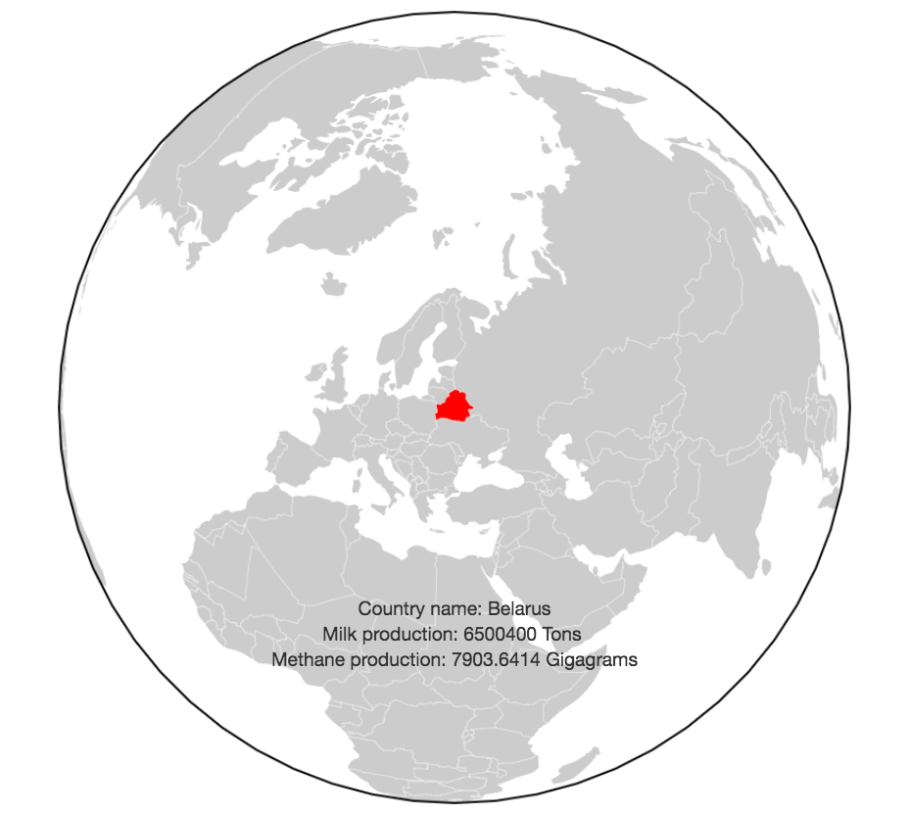

2. milk production bar chart:

User can click/tap anywhere on the globe to pause it from spinning. Once a pause is detected, a bar chart of milk production would be created.

The bar chart showcased the milk production data of top 5 countries against that of the country that was paused on. Data were mapped by linear scale with a domain from 0 to the largest of milk production number. If the country that was paused on happened to be one of the top 5 countries, the bar chart would combine the data and display 5 bars, instead of 6, under normal circumstance.

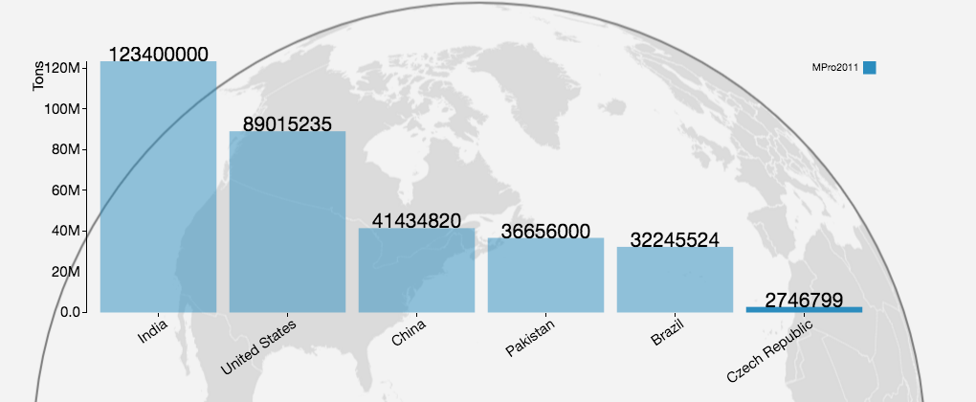

User also has the option to view data from a different year. When different year was selected, the data from that year of the same 6 countries would be retrieved and mapped to the bar chart.



When user clicked on the “resume” button, the bar chart will disappear and the globe will resume spinning, starting from the country that was paused on previously.

3. methane emission bar chart:

User can click/tap anywhere on the globe to pause it from spinning. Once a pause is detected, a bar chart of methane emission would be created.

The bar chart showcased the methane emission data of top 5 countries against that of the country that was paused on. Data were mapped by linear scale with a domain from 0 to the largest of methane emission number. If the country that was paused on happened to be one of the top 5 countries, the bar chart would combine the data and display 5 bars, instead of 6, under normal circumstance.

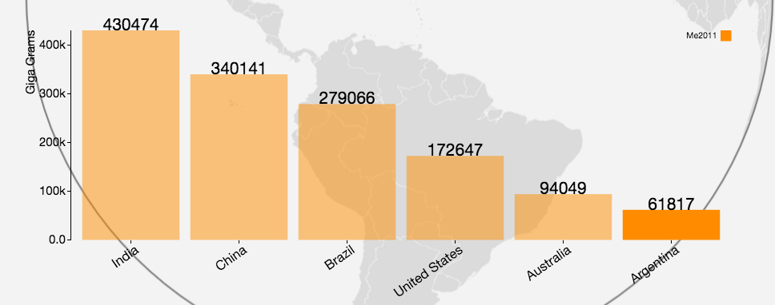

User also has the option to view data from a different year. When different year was selected, the data from that year of the same 6 countries would be retrieved and mapped to the bar chart.

When user clicked on the “resume” button, the bar chart will disappear and the globe will resume spinning, starting from the country that was paused on previously.

The Story

Methane has been known as one of the prevalent greenhouse gases that caused global warming. It is emitted by natural sources such as wetlands, as well as human activities such as leakage from natural gas systems, however we found that agricultural activities, such as milk production, have also become a primary source of methane emissions. Therefore, in this project, we set out to look at the top countries with milk production and its correlation with methane emission.

We found that countries have high milk production also tended to emit more agricultural related methane.